**General > Countries**  
  
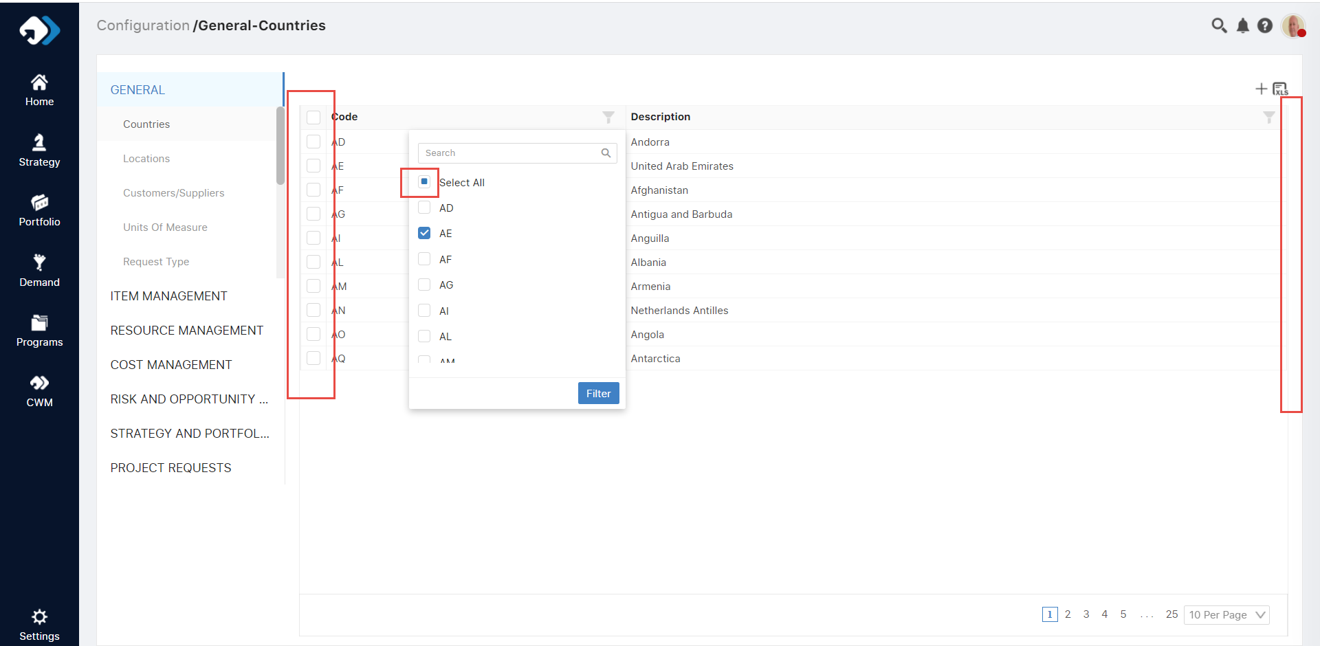  
  
Note: It’s a general issue – check all over the std code

**General > Location > Document Viewer**  
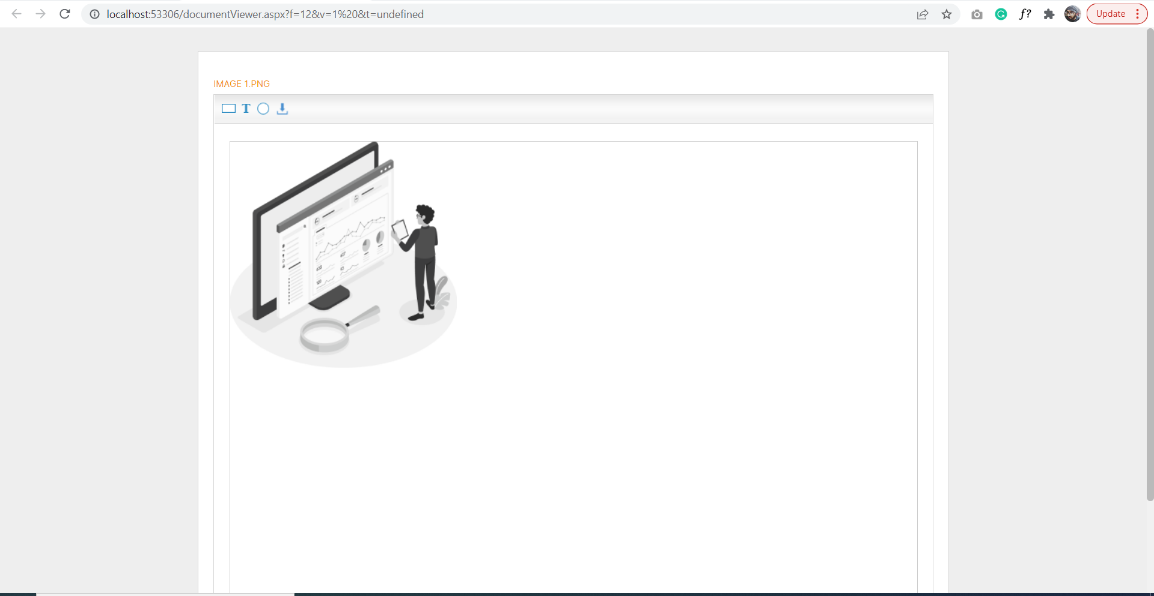  
  
Path: Location> Add data on grid > click on location document link > Document uploader popup > upload one image > Click on file name> Document viewer open - Need to align the design as per the standard

**General > Customer Supplier**   
  
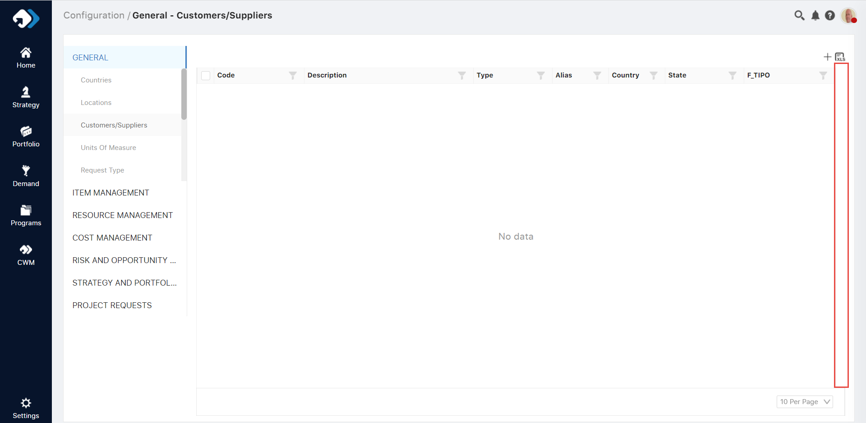  
Gap needs to be optimized  
  
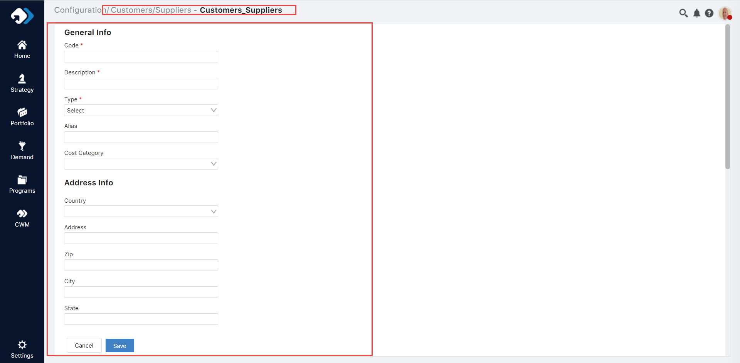  
Revamp the UI of this form as per the space like we did over the detail’s pages of another module

**General > Document Template**  
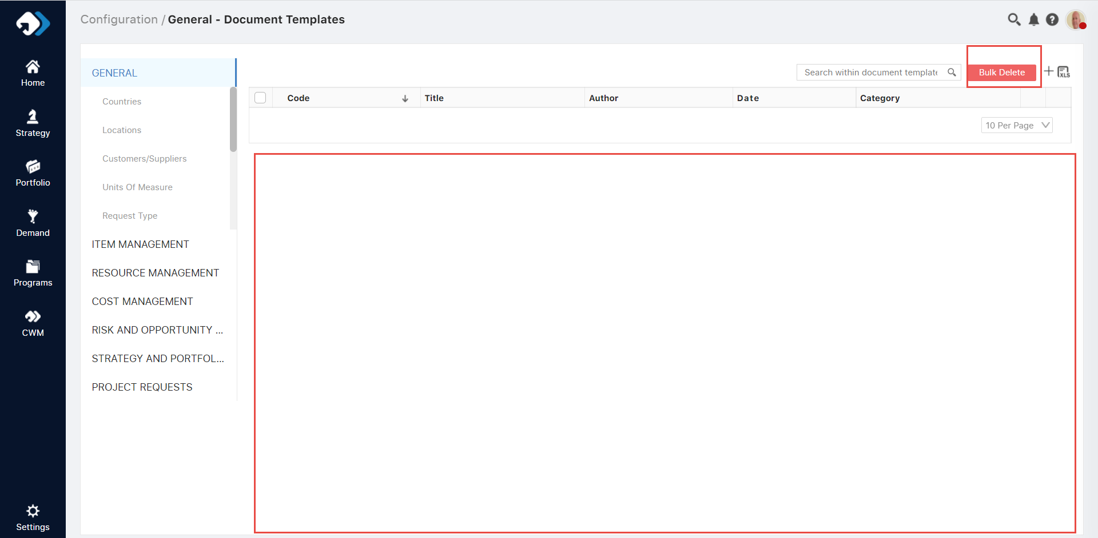  
  
The grid height should be similar like others and also there will be no required of bulk delete button option as like we are not giving this anywhere – Partial functional change required

Create Document Template

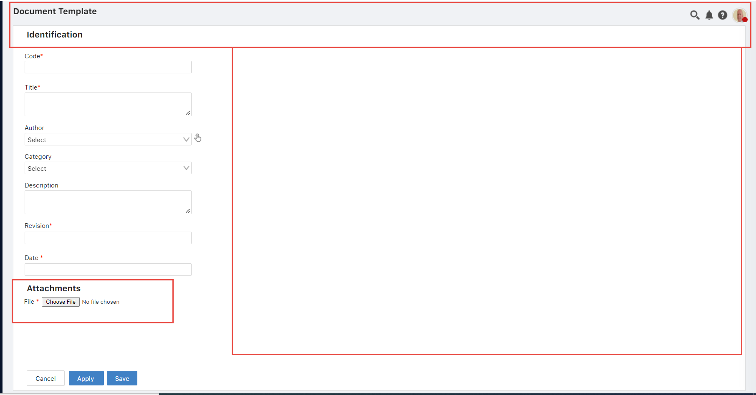  
  
Over document create – Need to align the form design with the create strategy or portfolio, etc. + maintain the gap between top header bar and below data container and manage the container height accordingly.

**General > Geographical Area > Create form**  
  
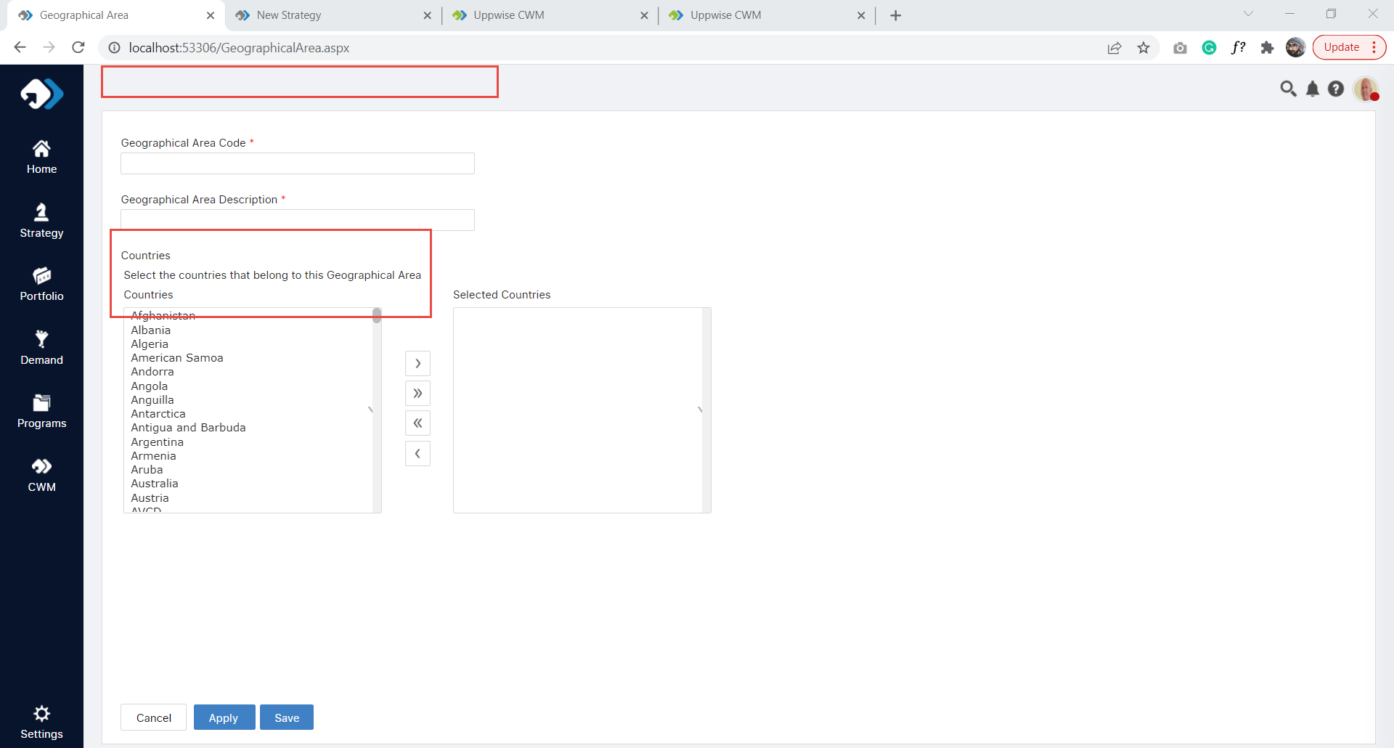  
  
Header is missing + Breadcrumb is not there + space between top header and below container + Alignment issues over the label

**General > Facility**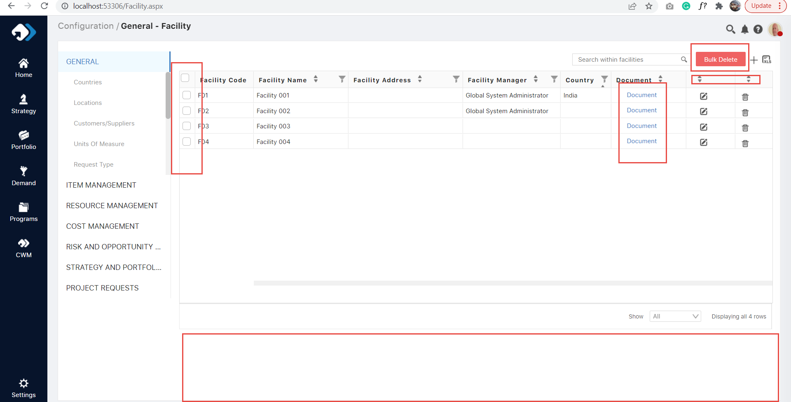Checkboxes are not aligned + Document text should be aligned left + Bulk Delete should not be there + Sorting will remove from the edit & delete column + Space management required and grid height

**General > COS Master Data**Additional Data popup  
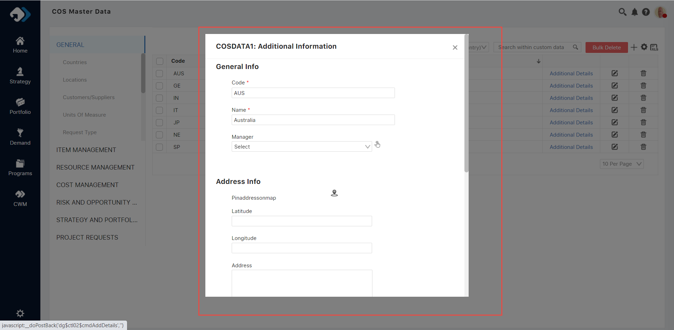  
  
Need to manage the whole UI + Flicker issue (functional)  
  
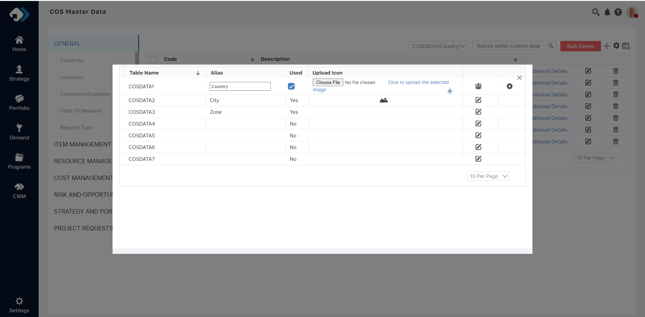  
  
Customize popup – should align as per the new design

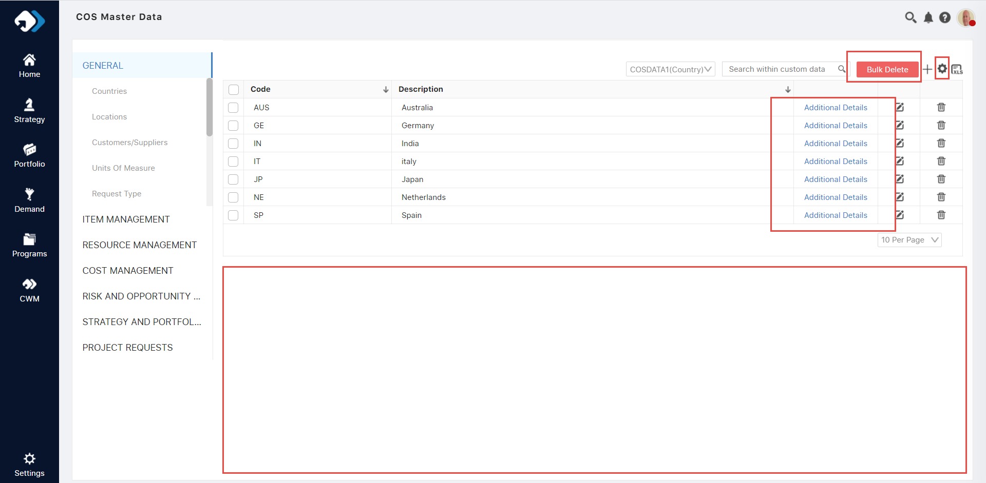  
  
Bulk Delete button not working here + Additional Detail Link should be left align + Setting icon & plus icon should replace the position